**Quiz Application**

**Do a Single Page Quiz Application with Following Requirements**

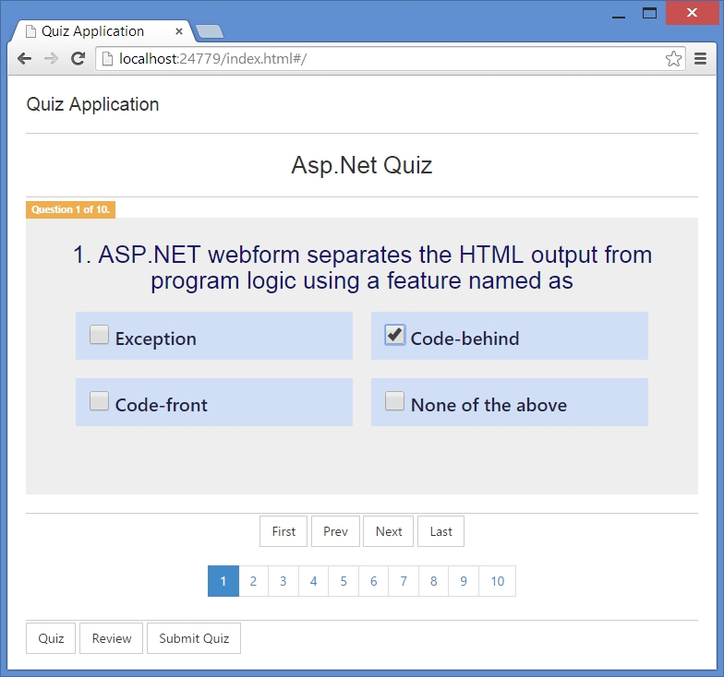

1. **Do a 10 Question Quiz with Provided Json Url.**
2. **Single Page Application (Page Should not Reload).**
3. **You Have to Ask One Question at a Time.**
4. **User Should Have only one Attempts on Quiz, If users Navigate to Next Page With Attempt Previous Button have to Disable.**
5. **Show a timer At Top of the Page – that each question has 60 Sec to Answer.**
6. **Show Score with at the end With Pie Chart.**

**Json Url :** https://gist.githubusercontent.com/saifsathisah/dd92d7477af41a875df6ee33e36bd74a/raw/0bcd49efcaac0af46f695c355e76fc5848fcedd0/QuizData.json